HARI  Ad-hoc Project  Funding Application Form | 2023-2024
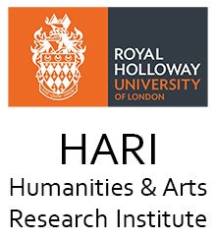

2023-2024
Project Funding Application
HARI is interested in sponsoring interdisciplinary events and projects in the Arts and Humanities. We are particularly keen on projects which will enhance the College’s research culture, build capacity in interdisciplinary research, and enable grant capture, including ‘proof of concept’ activities. HARI will seek to sponsor activities that focus on intellectual experimentation, networking, and impact and engagement.
Research must be of an interdisciplinary nature.
The maximum sum for which applicants can apply is £400. Applications should be made on the attached form. The form should be submitted to Richard Alston, as Director and colleagues are encouraged to discuss ideas informally before application.
Applications will be assessed by the following criteria
- Interdisciplinarity
- Quality and importance of project (including proof of concept)
- Enhancement of the Research Culture and Capacity Building

Please note that ‘normal’ research expenses should be met through School or Departmental Research Budgets.

HARI is also actively seeking to support interdisciplinary research groupings that are not formalised into Centres or similar institutional forms.

Name of Project Lead:
Department/School:
E-mail:
Date of Application:

- Do you already have funding for this project/ have you applied for other funding? If “yes”, please state which funding body and how much you have received/ applied for:

- Project aims (approx. 200 words) and contribution:

- Description of the project’s interdisciplinary contribution (150 words):

- Breakdown of costs (not to exceed £450):

- Timetable:

